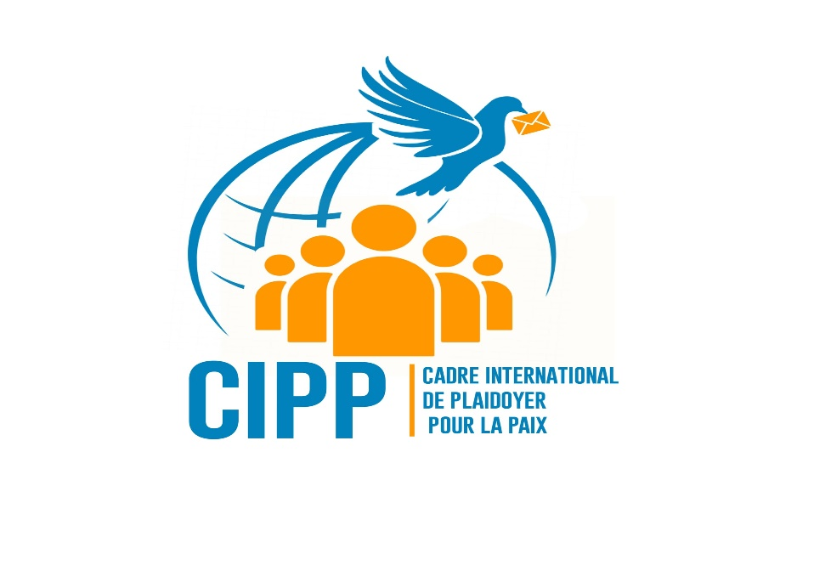T

**CADRE INTERNATIONAL DE PLAIDOYER POUR LA PAIX**

***+243 997759531/+243 815 179 090***

[cippasbl@gmail.com](mailto:cippasbl@gmail.com)

07, av. Révolution. Croisement des avenues Révolution et Salvias, 8ème Rue Quartier Résidentiel, Commune de Limete

**KINSHASA**

**PRESENTATION OF CADRE INTERNATIONAL DE PLAIDOYER POUR**

**LA PAIX**

**WHO ARE WE?**

**COORDINATING COMMITTEE**

**1. Coordinator: Prof. Roger MPONGO**

**2. Deputy Coordinator: Me Nathalie NANSHA**

**3. Rapporteur: Mr Philémon CHIKURU**

**4. Deputy Rapporteur: Me Prudence NKENGE**

**5. Treasurer: Dr Marcel BAHIMBA CIGWERHE**

**6. Advisors: Prof. Victor NABINO and Mr Moïse BALAGIZI**

Le Cadre International de Plaidoyer pour la Paix is set up because at present, no civil society initiative is envisaged to carry out advocacy at the level of international bodies for the return to peace in the Eastern Democratic Republic of Congo. Mechanisms have been activated by regional authorities to try to stop the escalation of violence through a negotiated solution but all these efforts have encountered resistance from the belligerents, with the complicity of countries that are predators of mineral resources and the complicit silence of the international community.

The CIPP would like to propose an alternative diplomacy, at the international level, in several areas including interuniversity relations, dialogue with the Government, Research and scientific innovations, especially in phytotherapies and African pharmacopoeias against chronic diseases (declared incurable), the strengthening of South-South and North-South network in matters of human rights and integral ecology, etc.

**SPECIALIZED TECHNICAL COMMISSIONS**:

1. **FRANCOPHONIE**

* Human rights and
* Interuniversity relations

The university offers a space for reflection, analysis and debate on societal issues. An apparently apolitical institution but where real politics is played out in the etymological sense of the term. Congolese professors, engaged in scientific mobility between the West and Africa, are an asset for alternative diplomacy to make the voice of the DRC heard. The same applies to foreign students, friends of the DRC, who conduct theses on the DRC. These “DRC specialists” would be potential ambassadors for our country to the international community.

1. **GOVERNANCE**

* Dialogue with civil society
* Dialogue with the Government

Political leaders should be privileged partners of our civil society. They are not adversaries to be fought or constantly bothered without prior dialogue. A constructive dialogue between the two poles is essential for peace and the development of a Nation.

1. **ECOLOGY AND ECONOMY** :

* Natural resources
* Distributive justice
* Environmental and ecological issues

The human environment and the natural environment mutually degrade each other. We cannot solve one without the other! A true ecology is constantly transformed into a social approach that integrates justice into discussions for the environment, to “listen to both the clamor of nature and the clamor of the poor” (Laudato si, 49). To say that the groans of the earth join those of the abandoned, the excluded and the voiceless.

1. **SOUTH-SOUTH and NORTH-SOUTH NETWORKS:**

**Essential for advocacy in a changing world. We have something to “give and receive” from each other.**

* Dialogue with the African Union
* African cultural specificities
* Artistic valorizations

1. **TECHNOLOGICAL RESEARCH AND INNOVATIONS**

* Health: African pharmacopoeias and phytotherapies
* New technologies and networking

We already have at our fingertips a functioning laboratory, action research whose products have been approved by the Institute for Research in Health Sciences (IRSS). Our Holistic, Environmental and Health Research Unit in Africa (URHESA) negotiates high-level sponsorship to secure our products and its Congolese researchers.

1. **YOUTH – PEACE – SECURITY**

* Cfr Resolution 2250 (2015) of the United Nations Security Council and its effective implementation.
* Importance of involving young women and young men in the establishment of lasting peace.
* Our African cultural specificity demands from us a dialogue and an exchange of expertise with female leaders engaged in the implementation of Resolution 1325 (2000) of the United Nations Security Council with a view to promoting the representation and participation of women to the prevention, management and protection of their rights…

1. **COMMUNICATIONS**

* Website, blog
* Design and social networks, etc.
* **Brief presentation of our LABORATORY**
* **URHESA** is **U**nité de **R**echerches **H**olistiques, **E**nvironnementales et **S**anitaires en **A**frique which focuses on African pharmacopoeias and phytotherapies in order to respond to the health limits of conventional medicine. It would like to serve as an alternative to these classic therapeutic limits against chronic diseases, declared, until now, incurable. These include sickle cell anemia, epilepsy, diabetes, kidney failure, hepatitis, male and female sterility, etc.
* We are a team of researchers, all university graduates including some professors engaged in scientific mobility between Europe and Africa. We are passionate about natural and environmental sciences with a view to effectively restoring fauna, flora and the health well-being of all living beings.
* Indeed, all our research is focused on the restoration, taxonomy, planting, popularization, gathering, preparation, transformation, analysis and administration of phytotherapeutic products to patients whose medical care escapes the control of conventional medicine health structures.